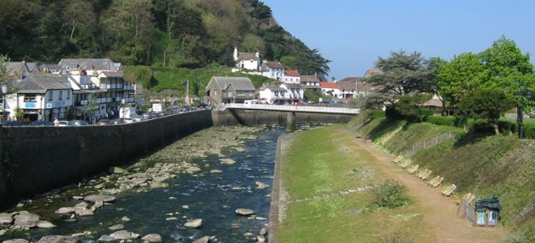

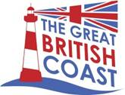
Lyn Valley Coastal Community Team
Economic Plan
January 2016
- Purpose
This Plan has been developed by the Lyn Valley Coastal Community Team (CCT) as an action plan for development of the visitor economy within the Lyn Valley. The CCT is led by Lynton and Lynmouth Town Council, supported by LETA (Lyn Economic and Tourism Alliance), a sub-committee of the Council, which includes primarily private sector stakeholders from the tourism industry, with support from the Town Council. LETA exists to enable co-ordination of local economic initiatives. This Plan has been developed as part of a nationwide initiative, supported by the Department for Communities and Local Government (DCLG), to enable economic growth within coastal areas.
The visitor economy is central to the health and prosperity of our community and is something that we must actively develop and manage to ensure that it delivers benefits for all in the future.
- Context
  - The local area
Lynton and Lynmouth, or the Lyn Valley as it is often known, is a small and peripheral coastal community of c. 4,900 population on the north coast of Devon close to the Somerset border and on the western side of Exmoor. Dubbed ‘Little Switzerland’, the Lyn Valley setting is stunning; a cleave in the towering wooded cliffs revealing the small fishing harbour where the East and West Lyn rivers meet the sea at Lynmouth. The harbour was once a significant port for landing herring. With growth around the harbour constrained by a dramatic topography, Lynton, on the cliffs 210 m above, grew as a linked community. The two communities are a civil parish governed by Lynton and Lynmouth Town Council.
Connections to other parts of the county are poor and public transport is very limited. The main area centre for North Devon district, Barnstaple, is 20 miles away (40 mins drive) and the nearest motorway, 50 miles away (1 hour 20 mins drive). The town’s peripherality is reflected by the Barbrook Filling Station, located 2 miles south of Lynmouth, being the only southern English filling station to secure the EU 5p fuel subsidy for peripheral rural areas.
Set within Exmoor National Park, the Lyn Valley has attracted visitors since the Victorian era and is famed for the Valley of Rocks and the water-powered Cliff Railway, which connects the twin communities; although many will remember the area for the flood disaster which swept half the town away after an August storm in 1952.
Today the Lyn Valley retains its traditional tourism offer of small B&B’s and guest houses, tea shops and souvenir outlets. Visitors attracted to the area tend to be those of an older demographic, as well as coastal walkers. The South West Coast Path and Tarka Trail both pass through the town, and Lynton and Lynmouth are destination/start points for the Two Moors Way (from Ivybridge in South Devon to Lynmouth); the Samaritans Way South West (from Bristol to Lynton), and the Coleridge Way (from Nether Stowey to Lynmouth).
The area covered by this plan encompasses the parishes of Lynton & Lynmouth, and Brendon & Countisbury (see Fig. 2.1).
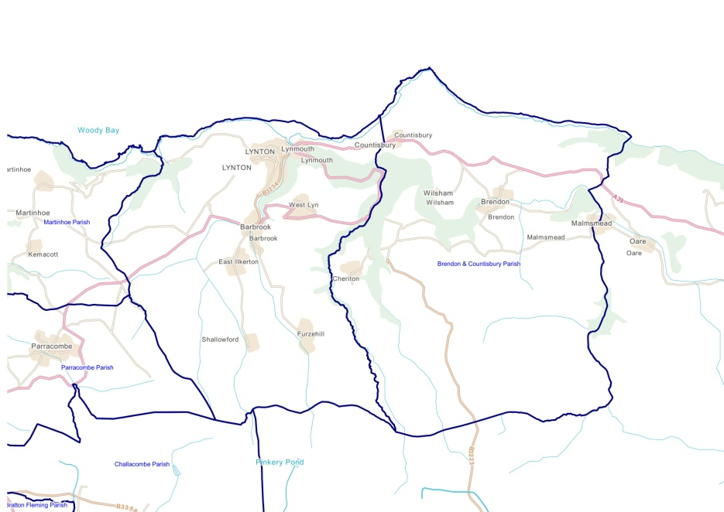
Figure 2.1 The CCT area – the parishes of Lynton & Lynmouth and Brendon & Countisbury
Lynton &
Lynmouth
Brendon & Countisbury

  - Community context
“We are a strong, self-reliant community which steps up to take care of its responsibilities and problems. For us to prosper, as well as needing a strong local economy we also have to meet the needs of the community and add to the assets it needs and values.” (The Lyn Plan 2013-2028)

Issues within the area highlighted in the Lynton & Lynmouth Neighbourhood Plan² include:
- An aging population and declining number of young people, with issues for key service delivery and sustainability.
- High property prices and availability of affordable homes for local people – “we have not met our affordable housing needs and some people have moved away and others are living in unsatisfactory housing conditions.”
- Opportunities for younger people to live and work in the area – “we also want to attract new people to live and work here, to add to our community and strengthen the local economy.”
- Availability of properties for older people wishing to 'downsize'.
- Provision of more accommodation for staff and seasonal workers in the hospitality sector.
- Increasing number of properties being used as second homes.
- Retention of services, both public and private.
- Protection and enhancement of the local environment, which is a key asset of the area.
Central to these community issues is the health of the local economy and particularly the visitor economy, which is the focus of this Economic Plan:
“The 'virtuous circle' linking the community and its housing needs, the local economy, and the local environment is important here. Services, both public and private, need people as customers. People need somewhere to live and many households also need to find employment. To protect and enhance local services and facilities we need to strengthen the community and the local economy as a whole.” (Lyn Plan 2013-2028)

  - The local economy
Key defining characteristics of the Lynton & Lynmouth economy are that it is rural, remote and, as a consequence, greatly self-reliant. Its distance from urban centres and the decline of traditional sectors and its historical reasons for being, as a fishing and trading port, are now largely gone. Today, its unique selling points are its natural environment and heritage which have underpinned its popularity as a tourism destination and attraction for staying and day visitors.
Whilst North Devon district has quite a mixed economy, employment within Lynton & Lynmouth is most distinctive. Tourism dominates the local economy. In 2011:
- More than half of all jobs in the area (54.4%) were within ‘accommodation & food services’ (not including self-employment), compared to North Devon (14.3%), Devon (10.1%) and the national picture (6.8%).
- Within the wider parishes of the town area, ‘arts, entertainment, recreation & other services’ accounted for a further 12.0% of employment, compared to a district average of only 3.4% and national average of 4.5%.
- Agriculture, although not registering as a major employer as many workers are self-employed, is still very important to the wider area, particularly on Exmoor, which is predominantly an upland farming area.
The very high dependence on tourism and recreation within a very rural area is both a strength and a weakness, with susceptibility to economic shocks and environmental risks such as Foot & Mouth disease and extreme weather. Local strategic priorities¹ therefore include:
- To support the local visitor economy to secure its future, to enable it to become stronger, to diversify and consolidate its resources.
- To attract new enterprises and business activity, including those in knowledge and technology sectors and craft and food businesses.
- To encourage innovation and new business activity.
- To create new, and upgrade existing, business premises within the area, such as workshops, storage units, higher quality offices and a business 'hub'.
- To encourage new enterprises to move to the area to boost and diversify the local economy and create new jobs.

  - Related initiatives
Other local projects and initiatives that are relevant to this Plan include:
Lynton & Lynmouth
- North Devon Tidal Demonstration Zone – waters off the coast at Lynton & Lynmouth have been designated a Tidal Demonstration Zone as part of the next generation Wave and Tidal Demonstration Zones for the trial of new marine renewable technologies “to accelerate the rate of wave and tidal current technology, to both increase the readiness of technologies and work towards cost reduction” (see Fig. 2.4). Every zone has appropriate wave or tidal energy resources and satisfies other criteria necessary for test and demonstration projects to be successful. The North Devon site has the potential to support the demonstration of tidal stream arrays with a generating capacity of up to 30MW for each project and offers collaboration opportunities with Plymouth, Bristol and Exeter Universities, support from the Local Enterprise Partnership with marine renewable energy as a priority for EU Structural Funds, and access to support from the South West Marine Energy Park
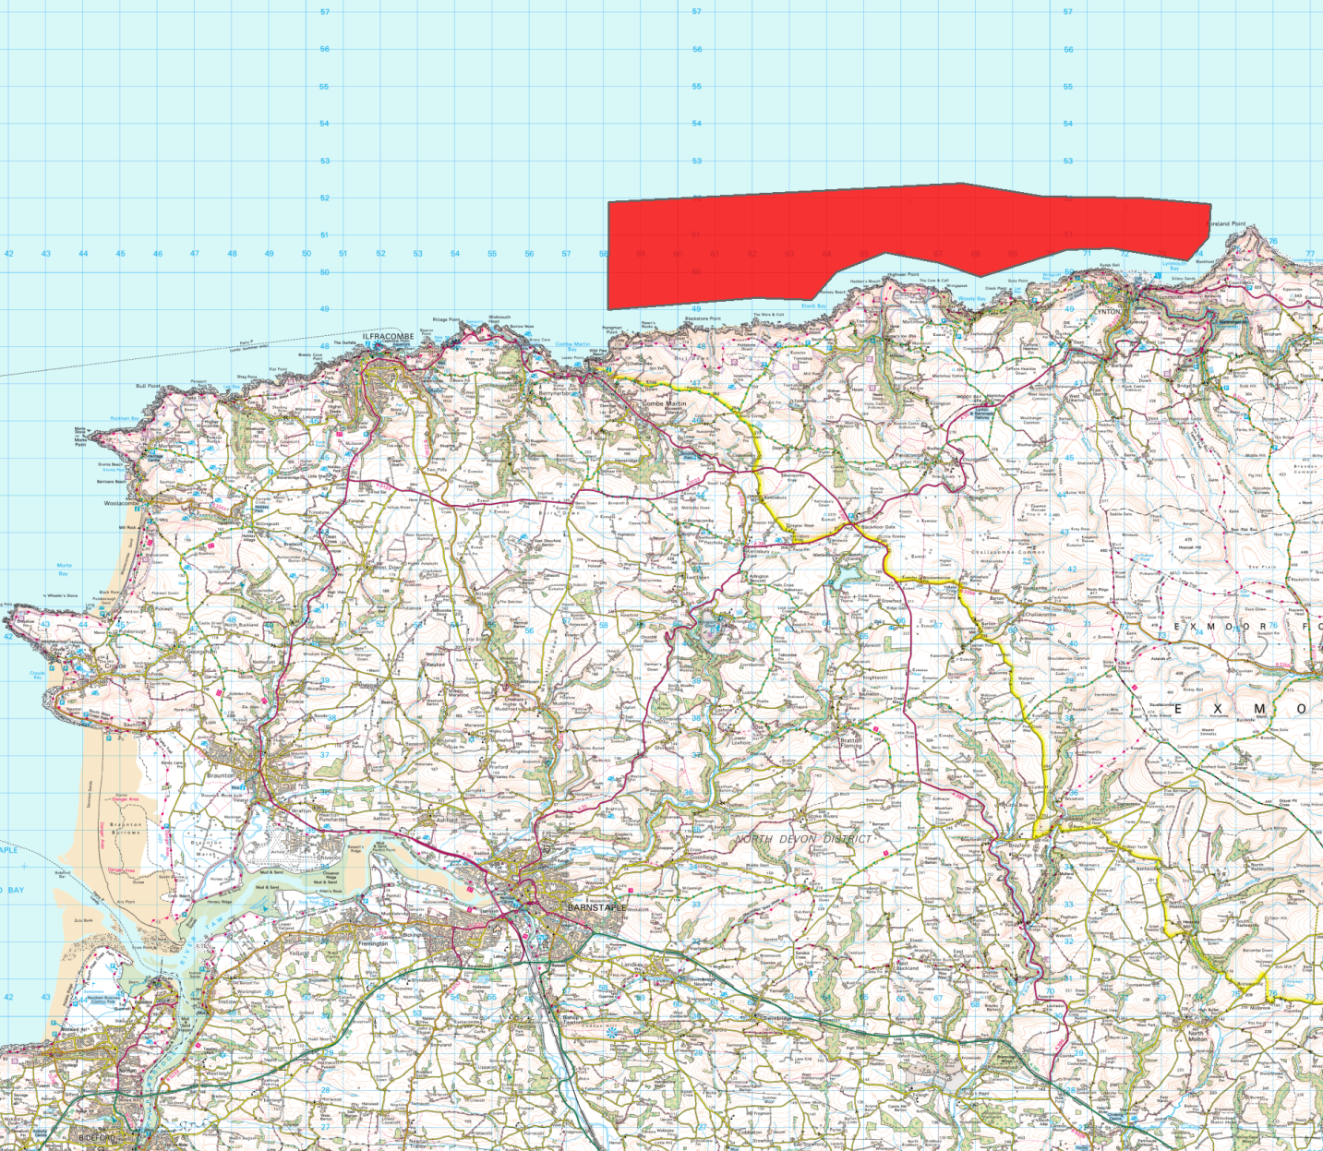
The Tidal Demonstration Zone presents a number of commercial opportunities for Lynton & Lynmouth, including port services for offshore installations, workboats for survey contracts, operations and management support, and accommodation and hospitality services. Since the map in Fig.2.4 was published, the Zone has been moved further eastwards, with Lynton & Lynmouth now central to the coastal boundary and well-placed as a service port.
Figure 2.4 North Devon Tidal Demonstration Zone
- Lynmouth (1952) Flood Memorial Hall – there are proposals to develop and update the exhibition and visitors centre commemorating the 1952 storm and flood disaster, when 34 people lost their lives and a further 420 were made homeless. The project will redesign and modernise the Lynmouth Flood Memorial Hall and exhibits therein, to tell the story of the flood disaster and the wider risks and consequences of environmental climate change to provide a rejuvenated visitor attraction. An application to the Coastal Revival Fund has been made. Subject to funding, an updated attraction could open within 3 months.

- Methods
  - About the Coastal Community Team
Members of the Lyn Valley Coastal Community Team include:
LETA - Lyn Economic and Tourism Alliance
Lynton & Lynmouth Tourist Information Centre
Lyn Community Development Trust
LACT – Lyn Association of Commerce and Tourism
The Cliff Railway
North Devon Council
Exmoor National Park Authority
Lyn and Barnstaple Railway
Lyn Financial Services
  - How our Plan was developed
This plan builds upon public consultation undertaken by LETA in 2013 through two business brunches to explore issues and opportunities within the local economy. The sessions outlined challenges, and proposed a range of actions, a number of which have been implemented. This work provided an outline framework to build upon.
Through an open event in November 2015 at Lynton Town Hall, the output of the 2013 work was revisited and reworked with a wider group of interested stakeholders. The event included facilitated discussion groups around four priority areas suggested by the 2013 work:
- Marketing and events
- Transport signage and connectivity
- Business support
- Developing the tourism product
All attendees had the opportunity to participate in each group, which included discussion of strengths, weaknesses, opportunities, threats, and of specific project ideas and relevant barriers to implementation. Everyone contributed to the prioritisation of short-listed projects. The output of this event forms the core basis of this plan, informed by statistical analysis and desk research around the core and related issues that the Plan is seeking to address. To the outline plans, detail has been added by the CCT in relation to the implementation of individual projects and through subsequent public consultation on a first draft version.

- Our Plan – aims & objectives

We recognise that tourism is central to the wealth, employment and sustainability of the Lyn Valley community, now and in the future, but we will need to work hard as a collective group to ensure that it delivers opportunities for all.
The aim of our Economic Plan is to safeguard and develop the Lyn Valley visitor economy for the benefit of businesses, residents and visitors alike, whilst protecting and enhancing the high quality environment upon which we depend, to meet changing tourism needs and to reach new markets.
Our key objectives are:
- To increase the number of high value staying and day visits to the Lyn Valley.
- To increase the number and diversity of businesses within the Lyn Valley.
- To increase year round employment opportunities, particularly for young people.
- To increase joint working between businesses, measured by the number of joint projects and the number of businesses involved.
- To enhance the environmental assets of the Lyn Valley for the benefit of all.

- Community needs and supporting data
Demography - Lynton & Lynmouth has an aging population raising issues of service delivery and sustainability within an isolated rural community and a shortage of opportunities for young people, whose numbers are reducing:
- In 2011, the Lynton and Lynmouth had a combined population of 1,647. The wider area, including the adjoining parishes of Martinhoe, Trentishoe, Parracombe, Challacombe, Brendon and Countisbury, had a population of 4,859.
- The town’s population is skewed towards higher age groups. At the last Census:
    - Only 24% of residents were aged less than 25, compared to 27% across North Devon District and the wider county.
    - One third (33%) were aged between 45 and 64, compared to 28% across the district and county.
    - 1 in 4 residents (25%) were aged 65 or above. The average age was 47, compared to 43 across the district and 44 across the county.
- In the last 10 years the population has grown by 4.2%
- By 2026, the number of residents in the 65-84 age band is expected to increase by a quarter (25.3%). In comparison, the number in the 20-44 age band is expected to fall by 15.4%.
Income – income levels are in line with the district, but, like may parts of the county, housing affordability is an issue:
- In 2008, average income within the town area was £25,500 p.a. compared with a district average of £26,000 and a county average of £26,800.
- At the last Census, only 1.2% of 16-59 year olds within the town were claiming Income Support, compared to 3.9% across the district, 3.4% across the county and 4.8% nationally.
- At an average of £207,702, house prices within the town were lower than the district (£216,673) and Devon averages (£233,819) but 29% higher than the national average (£161,281). In the previous 9 years, prices rose by 35% compared to national price rises of 24% - affordability is a growing issue.
- Almost three quarters of households (74%) were owned outright, compared to an average of 68% across the district and 70% across the county.
- Car ownership in Lynton & Lynmouth (90% of all households owning at least one vehicle) is higher than across the district (81%) and the county (83%), reflecting the physical isolation of the town and very limited public transport links.
- Levels of deprivation are low, with no Lower Super Output Areas (LSOAs) falling within the most deprived quartile for any measure and only crime just registering in the second most deprived quartile within one or more LSOAs.
Education & skills – skills levels in line with the county and district averages
- Skills levels at the last Census were in line with the county position and, if anything, slightly higher than the district average:
    - More than a quarter of residents (28%) aged over 16 had an NVQ Level 4 or higher qualification, compared to 28% across the county and only 23% in North Devon.
    - More than a fifth (22%) had no qualifications, in line with the county average (21%) and less than the district average (24%).
- At school level in 2011, attainment of qualifications was in line with the wider district but lower than the county and national positions:
    - Two thirds of children in the town (67%) achieved GCSEs at A*-C grades, compared to the district (67%), county (74%) and national picture (80%).
Economic activity – as an isolated community lacking large employers, the area is very much self-contained with a high proportion of self-employment:
- At the last Census, 1 in 4 residents (26%) aged 16 to 74 were self-employed, compared to only 15% across the district and 14% across Devon.
- Only 26% were in full-time employment (not including self-employed), which was significantly lower than the North Devon (33%) and Devon (34%) averages.
- At 3%, unemployment was in line with the district (3%) and county averages (3%).
- Only 0.2% of 19-64 years olds within the town were claiming Job Seekers Allowance, compared with 1.6% within the district, 1.8% within the county and 3.6% nationally.
- Almost one quarter (22%) of residents aged 16 and over worked from home, compared to only 10% within the district and 9% within the county.
Employment – the area’s employment is very dependent upon tourism:
- Tourism dominates the local economy – in 2011, more than half of all jobs (not including self-employment) within the area (54.4%) were within ‘accommodation & food services’, compared to North Devon (14.3%), Devon (10.1%) and the national picture (6.8%).
- The next most important sectors for employment were health (9.1%) and retail (8.3%), which are a long way down in terms of importance.
Tourism activity – since Victorian times, tourism has had a transformational impact on the local economy:
- In 2012, tourism brought into the Lynton & Lynmouth economy:
    - 79,000 staying visitor trips
    - 235,000 day visits
    - £29.4 million direct visitor spend
    - £30.1 million total visitor related spend
- Visitor-related spend in Lynton & Lynmouth supported an estimated 785 actual jobs (within the area and wider).
- Most staying visitors stayed in serviced accommodation (66%), with self-catering and camping/caravanning accounting for 14% and 15% of visits.
- The tourism sector locally has capacity to more than double the town’s population through accommodated visitors, in terms of bed spaces, self catering units, camping and caravan pitches.
Community issues - incomes, activities for young people and housing affordability are amongst the main issues identified by the community:
- Within a 2008 ‘Place Survey’ undertaken by Devon County Council, the top 5 rated things that the community identified as most needing improvement in the area were:
    - Wage levels and local cost of living (58%)
    - Activities for teenagers (45%)
    - Affordable decent housing (42%)
    - Job prospects (39%)
    - Public transport (29%)

- SWOT analysis of the visitor economy
This analysis was developed through discussion within the original business brunches in 2013.
Strengths | Weaknesses
- Loyal visitors - high repeat business  - Great produce, food & drink etc.  - Free on-street parking offers 'welcome'  - Unspoilt  - Quiet peaceful - no mobile service  - Great individual shops in Lynton  - Vast local knowledge  - Tourist Information Centre  - Growth in healthy lifestyle activity-based holidays  - Get away - escape  - Farmers Market  - The asset of the historic Lynmouth Pavilion | - Attractions closed in winter e.g. National Trust, Cliff Railway  - Lack of information on events for visitors, locally and wider area e.g. TIC board outside - events this week  - Lack of things for families to do in wet weather The quality of the high street offering in Lynmouth  - Perception that nothing is open  - Negative attitude of Met Office  - Cliff Railway closes  - Lack of mobility between Lynton and Lynmouth in the evening  - Facilities for disabled visitors  - Not enough signs directing to Lynton and Lynmouth  - Trade association not active enough  - Shabby buildings  - Weeds in roadways and paths  - Dog mess  - Improving highway priorities at Blackmoor Gate
Opportunities
- National TV advertising  - Create new attractions indoor and outdoor - a 'cross the gorge' cable ride, adventure ride - hang on tight! Swimming pool / spa  - Employ a marketing manager for 2/3 years  - Promote the area to coach parties - tell coach drivers there is easy, spacious parking in Lynton  - Create a beautiful children's playground  - Get more local websites to promote the area  - Build a Bandstand on the Manor  - Encourage film making, make a TV series here  - The school should be involved more in festivals etc.  - Heritage railway on our doorstep  - Park and ride from Blackmoor Gate by steam train  - Increase 2hr on road parking to 4hr and develop field by cemetery  - Bottom Meadow multi-storey car park? 500 spaces  - There are 50+ hotels – opportunity for a wholesaler or supermarket  - More indoor activities for the future - weather...  - Indoor children's play / entertainment area  - Links to outdoor groups - mountain bikers, Ramblers Association, Horse riders  - Fishing trips  - Use our history  - Sand on the beach  - Locally produced products - craft centre, candles, sheepskin shop, farmers market  - Exmoor food brand  - Turf maze on The Manor | - Change colour of Lynmouth Bridges - first impressions of rust stained white not attractive  - Promote as a cycling venue  - Big wheel 'Lynton Eye'  - Stop closing flood museum in winter  - Greater festival event programme  - Create 'attraction' at end of esplanade to link to 2000+ step path to Hollerday summit  - Lighthouse type structure, helter-skelter / fun park at esplanade  - Re-open seawater pool  - Take control and promote the Lynton / Lynmouth brand  - Enter National Park at Blackmoor Gate by steam railway  - Proper big signs for National Park  - Active trade association  - Sculptures - overland launch? Renew weir posts as something mad?  - Park and ride - Valley of Rock to Blue Ball Inn  - Weir at Lynmouth to create still water at low tide for play  - Paddle board franchise?  - Manor Green development  - West Lyn parking and cable car links to Lynton and Lynmouth  - Butcher, Baker, proper Deli  - Railway on our doorstep  - Better mobile phone signal  - Redesign Blackmoor Gate - uncover railway bridge as feature - roundabout - Gateway to Exmoor  - Greater use of the esplanade (car boot, parking etc.)
Threats
- Negative attitude of Met Office - 10 years rain?!  - Business Rates  - ENPA attitude to signage  - Road closures and road works in season  - Prolonged economic downturn  - ENPA would rather have affordable houses than investment for job creation  - Weather and lack of indoor stuff | - Inability to respond to changing visitor requirements through Planning constraints e.g. ‘glamping’  - Too much concentration on attracting first time visitors. Not enough on delighting then to come back!  - Broadband - what broadband?  - Planning restrictions on necessary improvements in guest facilities (e.g. double glazing in listed building)

- Our priorities
Our plan priorities respond to the identified strengths, weaknesses, opportunities and threats within our visitor economy:
Priority & rationale | Focus (output of 2013 events) | What we want to achieve
- Marketing & events  Making the most of what we have - bringing our assets to the attention of new and regular visitors and creating new reasons to visit (e.g. festivals) based on the strengths of the area | Many suggestions emerged relating to marketing and events, but one message that came across strongly was the need for a comprehensive, well publicised, well organised calendar of events.  In order to achieve this, a marketing and events group would need to be formed, including people who have time to implement the proposed events calendar.  As far as the types of events that people wanted to see – again there was a big mix, but the focus seemed to be around the twin town’s history and literary connections. With other ideas around the local food and natural environment (walking, running, cycling etc.) The idea of longer festivals (perhaps lasting up to a week) was popular.  In terms of marketing, a need for a brand and identity was noted, with all marketing, information, publicity etc. using the same marketing toolkit.  Marketing of the twin town’s assets in order to generate a revenue stream was suggested, with areas such as weddings, filming, venues, tidal swimming pool, esplanade being mentioned. | Joined up and targeted marketing activity to attract the attention of key customer groups  Within 6 months:  - Recruitment of Marketing Co-ordinator commenced  - Niche marketing activity  Within 5 years:  - Develop brand  - More sophisticated marketing strategy targeting key customer groups  - Develop events programme  - Develop capacity within businesses and the community e.g. skill
- Business support  Helping the tourism sector to improve quality and capacity for innovation through business support and peer group assistance | Businesses appeared to be holding their own, but felt that some of the lower quality shops and accommodation providers were letting the side down.  The business owners could see the benefit of more all-weather attractions, planned events, other activities, and were willing to give their support to these ventures.  The combination of a physical presence and e-commerce was seen to be the model that was working best, but required reasonable internet speeds to achieve. Some businesses needed some help in understanding the opportunities provided by e-commerce or an online presence, and also the potential of social media.  Training for businesses on the above topics was seen as a good starting point for supporting the local businesses. | A more cohesive and responsive tourism sector, innovating, growing and creating new employment  Within 6 months:  - Mail order initiatives commenced  - Planning workshops & clinics  Within 5 years:  - Business communications  - Build capacity within businesses and the community to deliver marketing and events, social media skills  - ‘Buy Local’ campaign
- Transport, signage & connectivity  Improving the way in which visitors are able to access and move within the area to encourage more and longer visits | The overwhelming message was that Lynton and Lynmouth need to be more clearly signposted, and that more needs to be made of the National Park.  It was felt that Lynton and Lynmouth needed to be signposted at a variety of different levels:  - Exmoor / Lynton and Lynmouth signposted from the M5  - Gateway to Devon indicated at County Gate  - Entrances to the National Park be clearly marked  - Lynton and Lynmouth clearly marked from Blackmoor Gate – make the junction a roundabout!  - Make sure the road classification brings people in the right way if they’re using Sat Nav  There was strong feeling that links with Exmoor were not well-developed. Opinion was that there was much more opportunity for Exmoor and the towns to work together and collaborate on projects such as transport and signage.  Once in Lynton and Lynmouth, visitors need clear signposting for drivers and pedestrians, and maps and fingerposts to help people find their way around.  Another big issue that was raised, was the movement of people between Lynton and Lynmouth. Very few people wanted to walk, so the only option to move between the towns is the cliff railway, taxi, or to drive.  Some kind of shuttle, park and ride, or other link between Lynton and Lynmouth was felt to be necessary in order for visitors to be able to make the most of what is on offer. | Better linkages between and within the twin communities and to other key tourism assets  Within 6 months:  - Develop signage audit  - Develop deliverable plan, working with key partners  Within 5 years:  - Difficulty of walking between Lynton and Lynmouth at night addressed  - Footpath enhancements
- Developing the product  Longer-term projects to enhance and diversify the range of attractions within the area to increase the number and range of visitors to the area | It was acknowledged that whilst it was essential to implement some ‘quick wins’ to help kick-start the local economy, a much longer term view with a clear strategy and business plan was what was needed.  This plan would incorporate all of the elements detailed above.  It was pointed out that it was hard to get people to think about the long-term plan, when making a living for the next 2 or 3 years was their main priority. But the benefit of a long-term plan was not disputed.  The economic strategy for Lynton and Lynmouth should then form part of the Neighbourhood Plan, and part of the wider North Devon Economic Strategy. | An enhanced and more diverse range of attractions appealing to high value visitor segments  Within 6 months:  - Key development and infrastructure projects identified  Within 5 years:  - Public art, sculpture  - Decorative lighting  - New sports facilities  - Implementation plans for key projects
- Our plan
  - Marketing & Events

Key project (title) | What it will deliver (type of outcomes & outputs) SMART | Who will lead & key partners | Estimated cost | Possible funding streams
ME1. Marketing Co-ordinator | Increased marketing activity to attract visitors, longer stays and expenditure | LETA | TBC | Awards for All, Leader 5
Description & rationale:  Overcome the main constraints to developing and delivering increased and joined-up marketing activity to promote the Lyn Valley – available time and resource.  Employ an experienced and skilled Marketing Co-ordinator |  | Resources required to deliver | Match funding  Bid writing
 |  | Next steps & dates | Develop outline job description  Short-term activity (within 12 months)

Key project (title) | What it will deliver (type of outcomes & outputs) SMART | Who will lead & key partners | Estimated cost | Possible funding streams
ME2. Lyn Valley Marketing Strategy | Joined up strategy leading to increased visits, stays and expenditure, businesses supported | LETA | TBC | Awards for All, Leader 5
Description & rationale:  - Develop a marketing strategy which includes better use of websites, TIC, ‘what’s app’.  - Review branding  - Identify and commit funding towards marketing – assess member subscription model  - Develop contact lists and data base to support joined up working and improved marketing  - Add website to all email communication |  | Resources required to deliver | Project management  Match funding  Bid writing
 |  | Next steps & dates | Develop project outline  Short-term activity (within 12 months)

Key project (title) | What it will deliver (type of outcomes & outputs) SMART | Who will lead & key partners | Estimated cost | Possible funding streams
ME3. Out of Season Activities | Increased visits, increased spend leading to new jobs | LETA, Marketing Co-ordinator, private sector | TBC | Leader 5
Description & rationale:  To develop a range of activities for visitors and a attract new visitors during the off peak period |  | Resources required to deliver | Match funding, project management, ND+ to offer business support through business support contracts
 |  | Next steps & dates | Leader 5 bid  Medium term activity 1-3 years

Key project (title) | What it will deliver (type of outcomes & outputs) SMART | Who will lead & key partners | Estimated cost | Possible funding streams
ME4. Social Media Training | Business supported, skills developed, increased use of social media | L&L Town Council | TBC | TBC
Description & rationale:  Deliver training and workshops in the local community for local businesses |  | Resources required to deliver | ND+ to explore this as part of their Business Support offer
 |  | Next steps & dates | See above – potential QUICK WIN

Key project (title) | What it will deliver (type of outcomes & outputs) SMART | Who will lead & key partners | Estimated cost | Possible funding streams
ME5. Lyn Valley Walking Trails | Longer visitor stays in the area, increased spend | CCT | TBC | Coastal Communities Fund, Leader 5
Description & rationale:  Create new attractions and invitations to explore:  - Develop walking trail of interest through the town  - Develop a fern trail promoting this plant of special interest |  | Resources required to deliver | Project management  Match funding
 |  | Next steps & dates | Form project group, outline and cost trails  Medium term activity 1-3 years

Key project (title) | What it will deliver (type of outcomes & outputs) SMART | Who will lead & key partners | Estimated cost | Possible funding streams
ME6. What’s Open out of Season? | Increased out of season visits and expenditure | LETA, Marketing Co-ordinator | Nil | N/A
Description & rationale:  Co-ordination and communication of what is open out of season to encourage out of season visits.  Encourage a position where there is no defined season, just a single year-round season. |  | Resources required to deliver | Resource co-ordination time  Communicate through TIC and website
 |  | Next steps & dates | Engage with attractions and communicate  potential QUICK WIN (within 12 months)

Key project (title) | What it will deliver (type of outcomes & outputs) SMART | Who will lead & key partners | Estimated cost | Possible funding streams
ME7. Online Booking System | Increased bookings, visits and expenditure | TIC | TBC | N/A
Description & rationale:  Explore a local booking system to avoid the costs of booking.com. Remove an obstacle to online booking |  | Resources required to deliver | Local research into alternative systems  Dissemination to the sector
 |  | Next steps & dates | Medium term activity 1-3 years

  - Business Support
Key project (title) | What it will deliver (type of outcomes & outputs) SMART | Who will lead & key partners | Estimated cost | Possible funding streams
BUS1. Promote the area | Increased visitor expenditure | LETA, L&L Town Council, Marketing Co-ordinator | TBC | Leader 5
Description & rationale:  Promote area through internet/sales/leaflets added to mail-ordered items from the Lyn Valley. Build on existing platforms to promote the area and offer the customer a wider package of information about attractions and services |  | Resources required to deliver | Marketing resource (see ME1)  Local business input/contribution  Match funding
 |  | Next steps & dates | See ME1  potential QUICK WIN (within 12 months)

Key project (title) | What it will deliver (type of outcomes & outputs) SMART | Who will lead & key partners | Estimated cost | Possible funding streams
BUS2. Business What’s On? | Increased visitor expenditure, triggered new business growth & employment opportunities | Marketing Co-ordinator | TBC | Leader 5
Description & rationale:  Develop a mechanism to keep businesses informed and up to date - enable businesses to identify opportunities to expand and develop their business offering |  | Resources required to deliver | Marketing resource (see ME1)  Local business input/contribution  Match funding
 |  | Next steps & dates | See ME1  Medium term activity 1-3 years

Key project (title) | What it will deliver (type of outcomes & outputs) SMART | Who will lead & key partners | Estimated cost | Possible funding streams
BUS3. Making the most of Social Media | Business supported, skills developed, increased use of social media | TBC | TBC | Leader 5
Description & rationale:  Develop and support the use of social media by businesses in the area. Promote online activity.  Increased web presence of businesses. Ongoing training and programme of learning. |  | Resources required to deliver | ND+ to explore how its business support contracts can support business development and learning in the area by delivering support within the community
 |  | Next steps & dates | TBC

Key project (title) | What it will deliver (type of outcomes & outputs) SMART | Who will lead & key partners | Estimated cost | Possible funding streams
BUS4. Map the offer – App the offer | Increased visits and visitor expenditure | LETA, Marketing Co-ordinator | TBC | Leader 5
Description & rationale:  Explore the potential to create interactive maps and Apps that promote businesses and the area |  | Resources required to deliver | Marketing resource (see ME1)  Local business input/contribution  Match funding
 |  | Next steps & dates | See ME1  Medium term activity 1-3 years

Key project (title) | What it will deliver (type of outcomes & outputs) SMART | Who will lead & key partners | Estimated cost | Possible funding streams
BUS5. Business Opening Times | Increased out of season visits and expenditure | TBC | Nil | N/A
Description & rationale:  Seek to address reduced opening times of shops, pubs, restaurants etc. out of season – work with shop landlords re. required opening times. Co-ordinate and develop an out of season offer extending opening times of businesses |  | Resources required to deliver | Project management resource  Local business input/agreement to trial
 |  | Next steps & dates | See ME1  Medium term activity 1-3 years

Key project (title) | What it will deliver (type of outcomes & outputs) SMART | Who will lead & key partners | Estimated cost | Possible funding streams
BUS6. Inward Investment | New growth & employment opportunities | NDC, ENPA | Nil | N/A
Description & rationale:  Promote inward investment through coordinated planning and economic policies  Overcome planning red-tape – support for businesses/ planning application workshops & clinics |  | Resources required to deliver | Officer time and resources
 |  | Next steps & dates | potential QUICK WIN (within 12 months)

Key project (title) | What it will deliver (type of outcomes & outputs) SMART | Who will lead & key partners | Estimated cost | Possible funding streams
BUS7. Buy Local | Retained and increased expenditure in the local economy | L&L Town Council | TBC | ENPA Sus Dev Fund, Leader 5
Description & rationale:  Explore and develop a buy local campaign to support local businesses and supply chain, and plug economic leakages |  | Resources required to deliver | Project management  Match funding  Bid writing
 |  | Next steps & dates | Medium term activity 1-3 years

  - Transport, Signage & Connectivity
Key project (title) | What it will deliver (type of outcomes & outputs) SMART | Who will lead & key partners | Estimated cost | Possible funding streams
TSC1. Parking Initiatives | Increased visits and expenditure | L&L Town Council, NDC, DCC | TBC | Leader 5
Description & rationale:  - Park and Ride – lack of parking spaces in Lynton to accommodate visitors. Develop tourist bus – linking car parking and Lynton and Lynmouth to improve visitor access  - Review parking charges to promote better use of car parks  - Need for clear information on Parking |  | Resources required to deliver | - Leader5 project idea submitted in 2015 – unclear if this would meet the stringent criteria for Leader5 recently published  - Task and Finish group to look at car parking charges and explore options  - Review all communication/media materials to improve understanding
 |  | Next steps & dates | TBC

Key project (title) | What it will deliver (type of outcomes & outputs) SMART | Who will lead & key partners | Estimated cost | Possible funding streams
TSC2. Signage | Increased access and visits, increased expenditure | L&L Town Council, ENPA, DCC | TBC | TBC
Description & rationale:  Improve awareness and access to the Lyn Valley area. Review and improve signage at key access and connecting points across North Devon e.g. Aller Cross. Explore the potential for branded signage at key points e.g. Exmoor brand signs. |  | Resources required to deliver | Project management time  Budget
 |  | Next steps & dates | TBC  Medium term activity 1-3 years

Key project (title) | What it will deliver (type of outcomes & outputs) SMART | Who will lead & key partners | Estimated cost | Possible funding streams
TSC3. Cliff Railway Connectivity | Increased out of season visits and expenditure | LETA | N/A | N/A
Description & rationale:  Improve connections between Lynton and Lynmouth. The Cliff Railway has limited opening times which affects visitor numbers and length of stay. Explore with the operator scope for extending operating times to take account of weather/ time of year and events. |  | Resources required to deliver | Project management time
 |  | Next steps & dates | Discussions with Cliff Railway

Key project (title) | What it will deliver (type of outcomes & outputs) SMART | Who will lead & key partners | Estimated cost | Possible funding streams
TSC4. Bus route enhancements | Increased visits and expenditure across the area | LETA | TBC | TBC
Description & rationale: To overcome barriers of limited public transport and connections between the two villages:  - Bus routes – need for better information  - Establish a bus loop connecting the communities |  | Resources required to deliver | Project management time
 |  | Next steps & dates | Review information and work with DCC and bus company to improve routes and communication.  Link this work to the potential tourist bus/ park and ride project  Medium term activity 1-3 years

Key project (title) | What it will deliver (type of outcomes & outputs) SMART | Who will lead & key partners | Estimated cost | Possible funding streams
TSC5. Mobile signal | Enhanced visits, longer stays | LETA, ENPA mobile phone companies | TBC | TBC
Description & rationale:  Need to improve mobile signal for the local area to benefit both businesses and visitors |  | Resources required to deliver | Project management time
 |  | Next steps & dates | Discussions with mobile phone companies  Longer-term activity 3 years+

Key project (title) | What it will deliver (type of outcomes & outputs) SMART | Who will lead & key partners | Estimated cost | Possible funding streams
TSC6. Finger Posts | Increased visits & expenditure | LETA | TBC | Coastal Communities Fund, Leader 5
Description & rationale:  Introduce finger posts at key points in the area to promote walks and trails |  | Resources required to deliver | Project management & volunteer time  Match funding
 |  | Next steps & dates | Medium term activity 1-3 years

Key project (title) | What it will deliver (type of outcomes & outputs) SMART | Who will lead & key partners | Estimated cost | Possible funding streams
TSC7. Cliff Railway Footpath Enhancement | Improved connectivity and access | L&L Town Council, NDC | TBC | TBC
Description & rationale:  Cliff railway footpath slippery and requires improved signage |  | Resources required to deliver | Project management  Budget
 |  | Next steps & dates | Review safety/signage of footpath and identify improvements  Medium term activity 1-3 years
  - Product Development
Key project (title) | What it will deliver (type of outcomes & outputs) SMART | Who will lead & key partners | Estimated cost | Possible funding streams
PD1. Art & Light | Enhancing the visitor product to encourage increased visits | LETA, private sector, arts groups | TBC | Coastal Communities Fund, Leader 5
Description & rationale:  Installation of public art/sculpture and decorative lighting/beacons to develop new visitor markets and attract out of hours visits. |  | Resources required to deliver | Project management & co-ordination
 |  | Next steps & dates | Developing and scoping project ideas  Longer-term activity 3 years+

Key project (title) | What it will deliver (type of outcomes & outputs) SMART | Who will lead & key partners | Estimated cost | Possible funding streams
PD2. Sports Activities | Enhancing the visitor product to encourage increased visits | LETA, private sector, arts groups | TBC | TBC
Description & rationale:  Develop a range of facilities for sports activities to cater for new visitor markets e.g. extreme cycling trail, Fitness Trail, Tree Top Trail, Dry Ski slope/ tobogganing |  | Resources required to deliver | Project management & development
 |  | Next steps & dates | Developing and scoping project ideas  Longer-term activity 3 years+

Key project (title) | What it will deliver (type of outcomes & outputs) SMART | Who will lead & key partners | Estimated cost | Possible funding streams
PD3. Games & Recreation | Enhancing the visitor product to encourage increased visits | LETA, L&L Town Council, private land owners, sports clubs | TBC | TBC
Description & rationale:  Develop a range of facilities for games & recreation activities to cater for new visitor markets e.g.  golf, boules |  | Resources required to deliver | Project management & co-ordination
 |  | Next steps & dates | Developing and scoping project ideas  Longer-term activity 3 years+

Key project (title) | What it will deliver (type of outcomes & outputs) SMART | Who will lead & key partners | Estimated cost | Possible funding streams
PD4. Tourism infrastructure | Enhancing the visitor product to encourage increased visits | LETA, Cliff Railway, L&B Railway, private sector land owners | TBC | TBC
Description & rationale:  Significant developments to create additional reasons to visit the Lyn Valley e.g. extension of the Lynton & Barnstaple Railway, a new cable car, a new bridge/wire |  | Resources required to deliver | Project management  Funding  Operational partners
 |  | Next steps & dates | Developing and scoping project ideas  Longer-term activity 3 years+

- Barriers & risks to implementing our plan

Identified barriers/risks | How we will manage/overcome
- Securing funding for feasibility and development work in order to bid into funding opportunities | - Prioritise and focus on the most important project initiatives  - Through partnership working, pool resources to maximise value and capacity  - Work closely with the private sector to share resources and maximise value
- Obtaining planning permission for the range of project ideas | - Early two-way engagement with the Planning Authority for them to understand our aspirations and for us to understand the planning constraints  - Prioritise focus on areas of common agreement  - Develop ongoing working relationship at a strategic level
- Delay or non-delivery of key projects | - Maintain focus of the CCT on the progress of key projects  - All projects to have individual project owners, who report on progress
- Obtaining public sector funding for identified transport enhancement schemes | - Early dialogue with DCC about what we are seeking to achieve

Census 2011 – population for the Lynton & Lynmouth town area, including the parishes of Brendon, Challacombe, Countisbury, Martinhoe, Parracombe and Trentishoe
The Lyn Plan 2013 – 2028 Examination Version March 2013
Office for National Statistics (ONS), 2011
Census 2011
Devon County Council Population Estimates 2010
Estimates based on Experian’s Mosaic Household dataset 2008
Land Registry 2011
Indices of Deprivation 2010
Devon County Council, Children’s & Young People’s Directorate, June 2011
ONS 2011
The South West Tourism Research Company

